Training Project Laboratory Report

**Name : Abderrahmen Malouche**

Neptun: BCZ07V

Beevolve

Description of the project:

The project is a gaming website , where people can get coached from professionals and streamers , in order to improve their skills in gaming industry and that covers mostly the famous games all over the world

Tasks required for the week:

( Tasks you were asked or planned to do in this week, mostly decided in the previous week)

* Creating the landing page , log in and sign in pages for the website
* Finish learning the React.js Library
* Start with Node.js

Tasks done this week:

( Tasks that you actually finished this week, from the previous list or more)

* Finished the whole landing page
* Finished Learning React.js

Code Screenshots:

( Insert some screen shots of your code that you wrote this week, in case your work includes other tasks than coding (e.g., design) include them too)

Results Screenshots:

( If you start getting any results or output of the project insert some screenshots here even if they are not 100% complete)

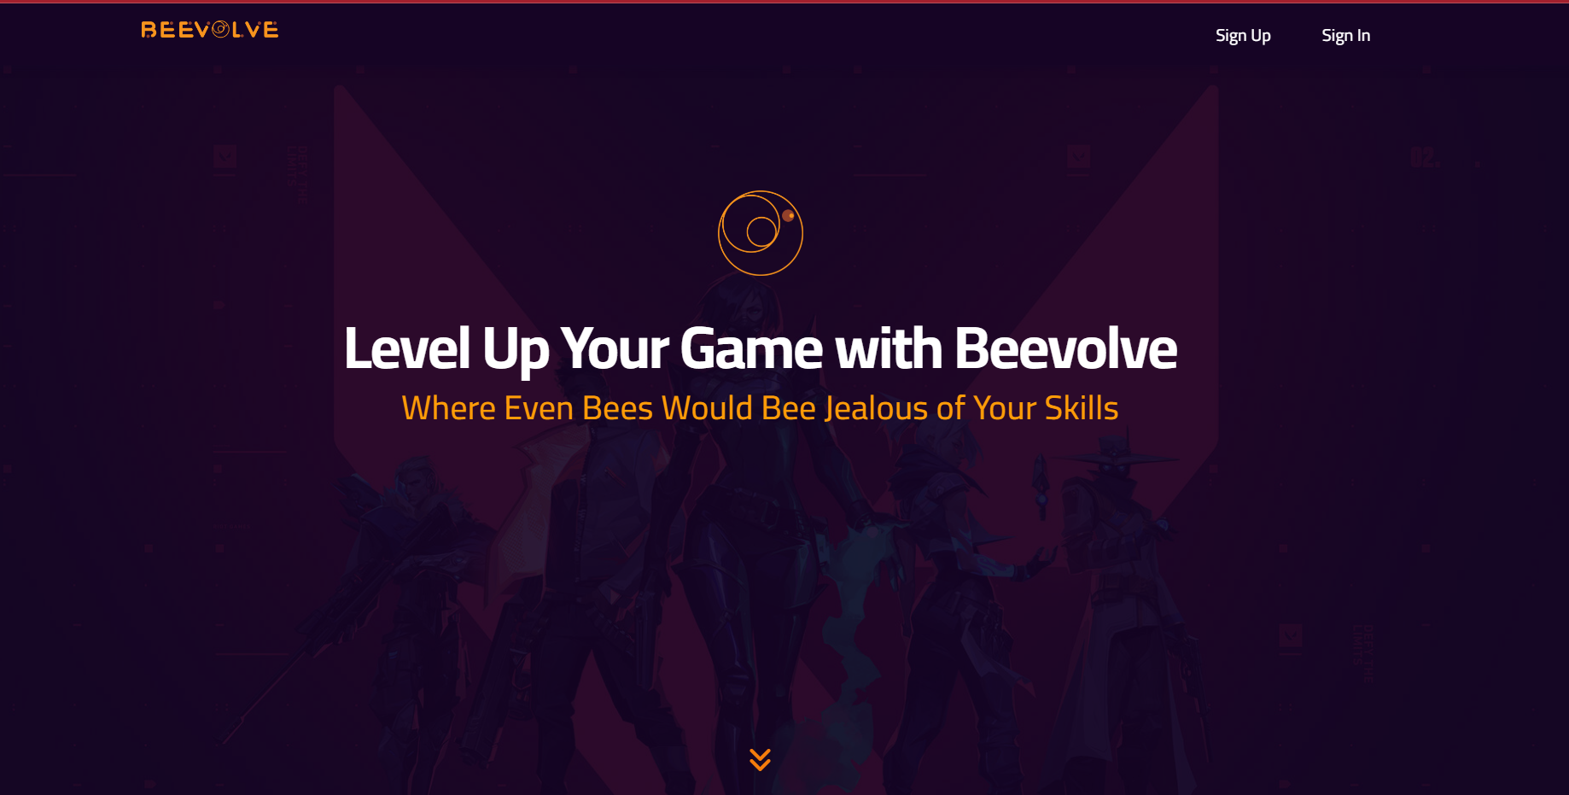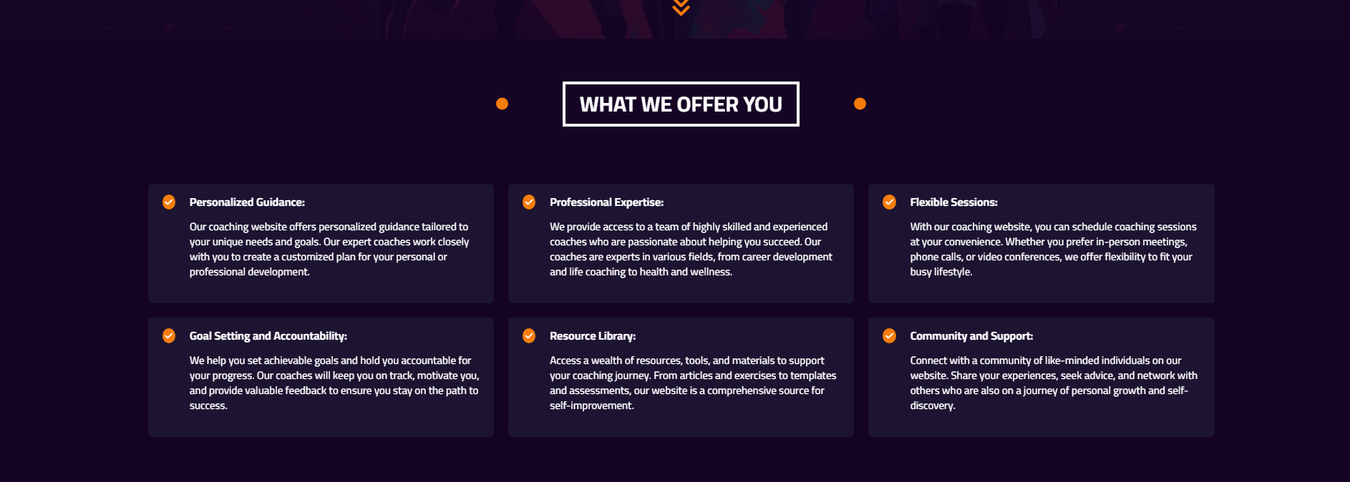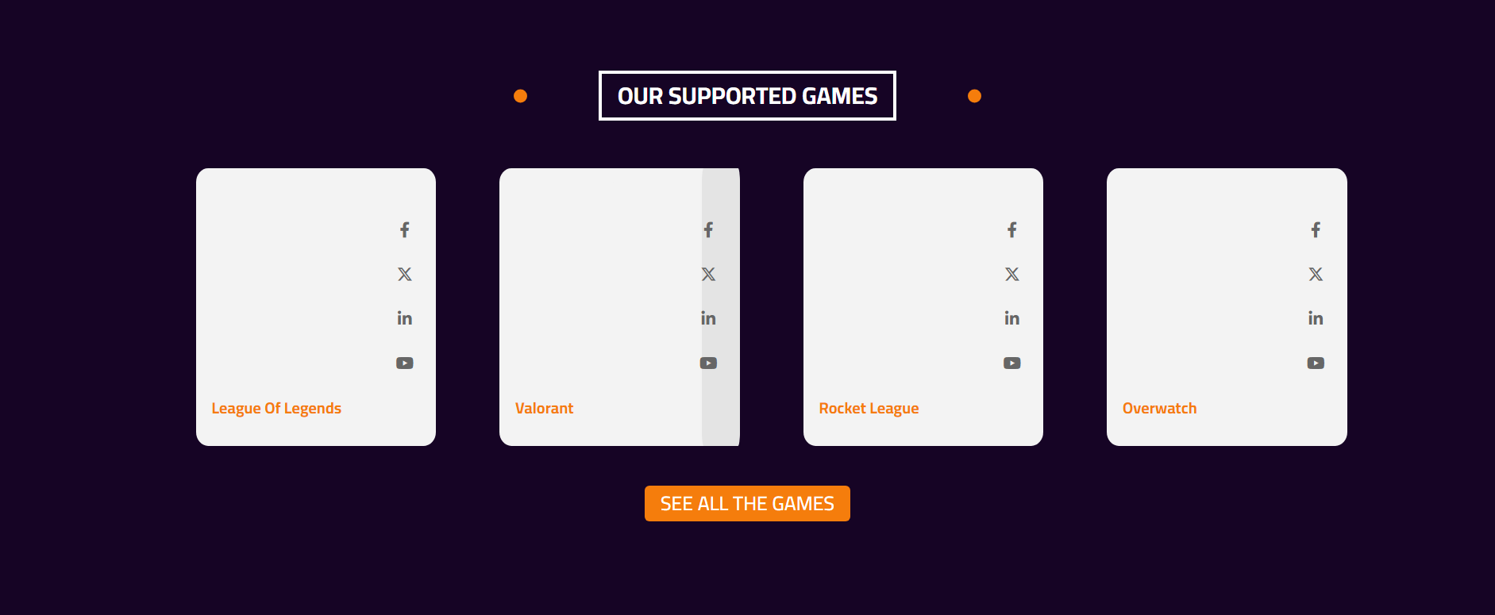

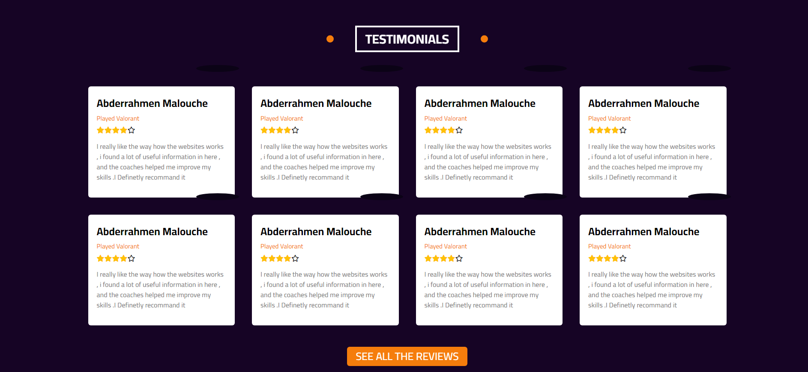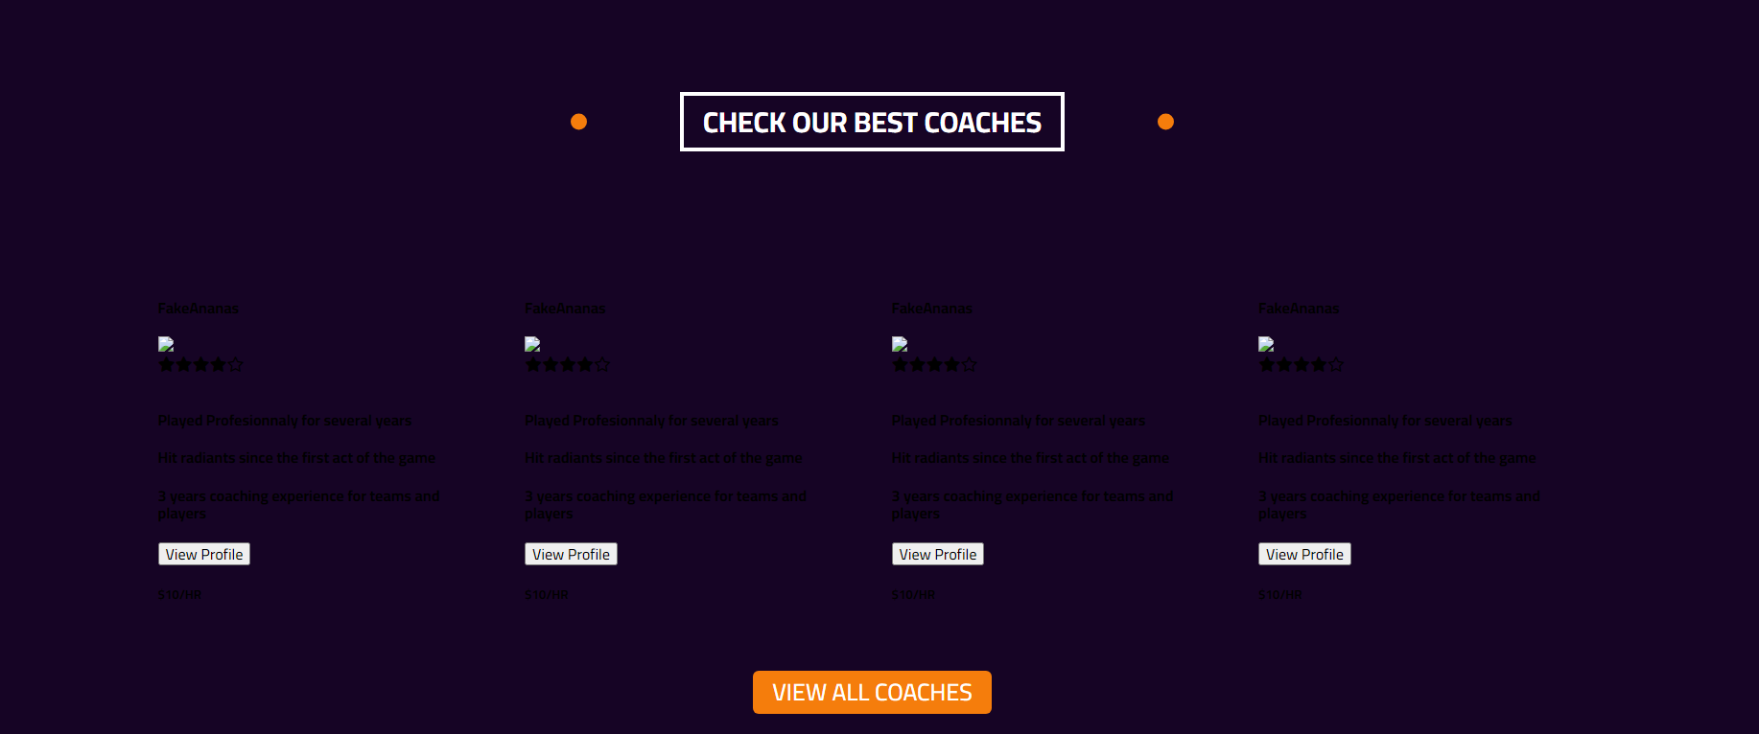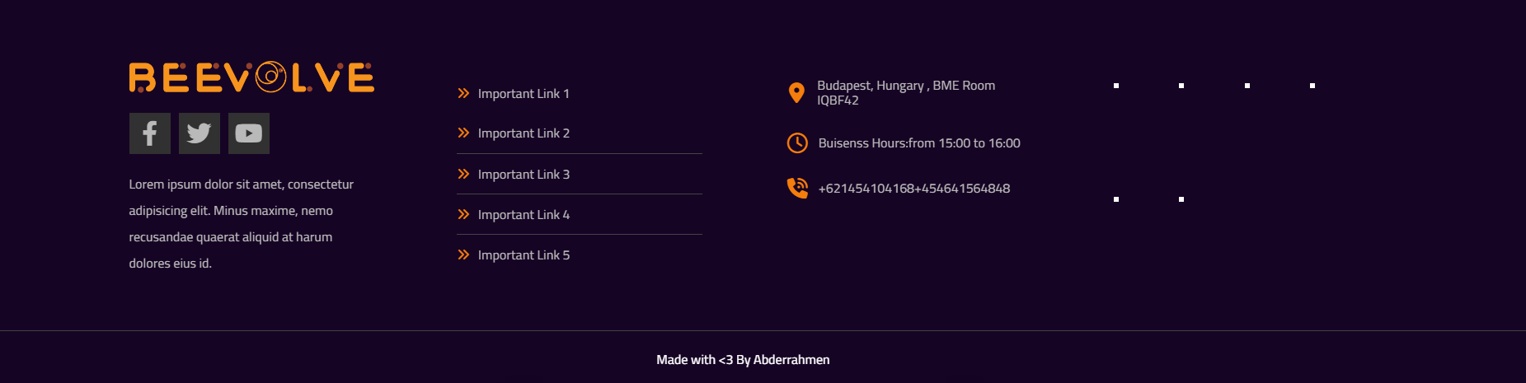

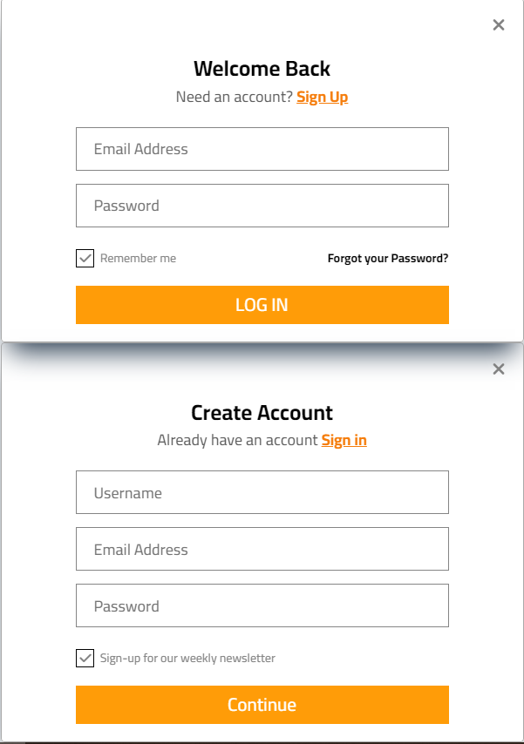

Tasks to be done next week:

( Tasks you are planning to do in the next week)

* **Finish all the front end of the websites and work with virtual API ( just hard created data until I finish the Backend)**
* **Start with the database and API**

Notes (optional) :

( If you have any question or note, write it here)

If anyone want to run the project , you simply have to Type “ npm start” in the terminal